Playground Charter

**Everyone** has the right to feel safe and happy, including those with a disability.

**Everyone’s** thoughts and feelings will be listened to and taken seriously. Everyone has the right to play with who they want to.

(Article 12) 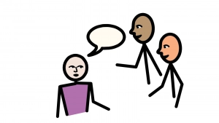

**Everyone** has the right to be protected from being hurt or badly treated.

**Everyone** has the right to have fun, relax and play.

KITE Values