KITE Values

**Everyone** has the right to eat healthy food and drink clean water so that they can live & grow. (Article 6)  (Article 24) 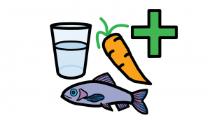

**Everyone’s** thoughts and feelings will be listened to and taken seriously.

**Everyone** has the right to be protected from   
being hurt or badly treated.

Canteen Charter