Introduction
In our recent Homework survey (October and November 2019), both parents and pupils at St Andrews Primary School indicated that homework was a valuable addition to the work which children do in school.
At St Andrews Primary School, we believe that homework helps children to consolidate knowledge and skills learned in class and promotes greater involvement of parents in their children’s education.
This policy has been prepared after consultation with parents, pupils and staff of St Andrews Primary School. We hope to ensure that we have a shared understanding and knowledge of what we are trying to achieve.

Aims
The aims and purposes of setting homework are:
- to support and build on classwork
- to make parents aware of the work children are doing in school
- to encourage children to work independently
- to promote good study habits to train pupils to plan and organise their time effectively
- to allow preparation for future classwork
- to encourage pupils to take responsibility for their own learning

Types of Homework
Homework can give children extra practice in skills that they have learned in school e.g. in Reading, Spelling and Maths. This additional practice can help the child’s confidence, mental agility and fluency and can reinforce what they have been taught.
Our consultation revealed that many parents and pupils felt that homework should be set weekly and that pupils should receive regular homework including Spelling, Reading and Maths. In general, the amount of time spent on homework increases gradually, from Primary 1 onwards.
At St Andrews Primary School, homework will be given out on a weekly basis – allowing flexibility and freedom of choice. Homework will be handed out and tasks briefly explained by the class teacher on a Monday or possibly twice weekly for Reading homework.

Homework at St Andrews Primary School
Class | Homework
P1 | - Sound practice – 2 sounds per week and some consolidation weeks  - Key Word practice  - Occasional Maths activities  - Reading
P2 - 4 | - Reading  - Key words/ Sounds/ Spelling activities  - Maths activities  - Big Maths Online  - Active Learn Maths Games  - Mathletics Games  - Occasional simple research
P5 - 7 | - Reading  - Key words/ Sounds/ Spelling activities  - Maths activities  - Big Maths Online  - Active Learn Maths Games  - Mathletics Games  - Google Classroom/ Glow  - Simple research  - Topic-related Activities

Reading
Reading homework will include practising pages at home that have already been read in class or teachers giving children the chance to take home a novel of their choice to read.
Some reading strategies include:
- Prior Knowledge – using what we know to help us understand what we read
- Words and Phrases – using words, phrases and punctuation to help us read with fluency and understanding
- Visualisation – Using pictures to communicate our understanding of what we read
- Inferences – Using the clues we find in the text to help us understand what we read
- Main Ideas – Thinking about the main points in the text to help us understand what we read
- Summarising – Using the main ideas to summarise and understand what we read
- What makes a good reader? – Reading with clarity(clearly), expression (changing the voice to show feeling), intonation (changing the pitch), fluency (speed and accuracy) and recognition of punctuation marks.
Spelling/ Sounds/ Key Words
Spelling homework will include children being given a list of words or sounds to practise using a strategy of their choice. Spelling homework will be given out on a Monday.
Some spelling strategies include:
- Mnemonic – e.g. because – big elephants can always understand small elephants. Pupils learn them more easily if they are funny or if they make them up themselves.
- Breaking it up into syllables – orally [often called ‘spell speak’] eg home-work
- Spelling rules – e.g. ‘i before e except after c’. 90% of words actually follow the rules
- Analogy – If you know how to spell television and headphone you can probably spell telephone, if you know how to spell light, you can spell bright
- Words inside words – strategies ‘rate’
- Rhyming – finding words that rhyme
- Knowledge and use of phonics – using elkonin boxes or the diacritical spelling code
  - Compound words – break/fast – breakfast

Teachers may choose to create a Spelling Homework Activity Grid to allow pupils flexibility and choice for how they wish to practise their spelling words. For example:
Put your words in alphabetical order | Write the definition for each of your words. | Group words together with the same number of syllables.
Hunt for other words that have the same pattern as your spelling words. | Separate your words into nouns, pronouns, adjectives, or verbs. | Write a rhyming word next to each of your spelling words.

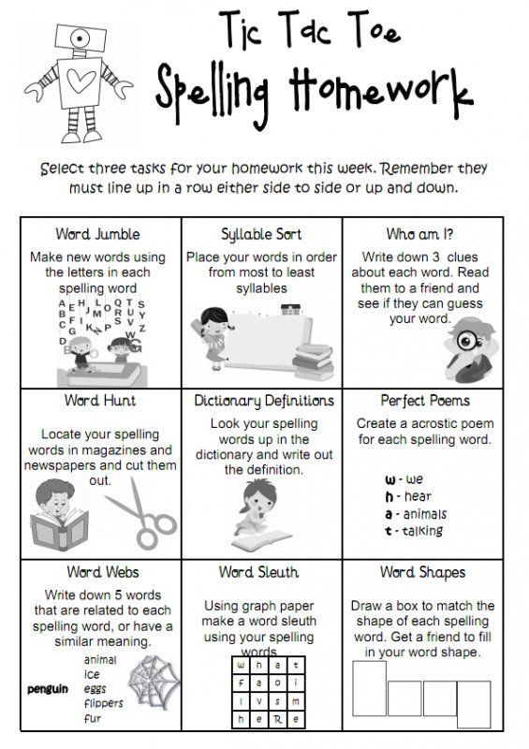

Maths
Maths homework may include practising Big Maths Learn Its and CLIC steps and times tables or playing online games that reinforce what is being taught in class e.g. Active Learn Maths games, Mathletics games etc. It may also occasionally include giving children activities and/or resources home to practise what is being learned in class e.g. Numicon resources in p1.

Topic/ Simple Research
On occasion, children will be set homework relating to the children’s Learning Context or an area of the curriculum other than Literacy or Maths. This may include asking children to complete some simple research or take something in from home about a particular subject.

Google Classroom
Some teachers in St Andrews Primary School use Google Classroom or Glow to set homework for the children online. Teachers may choose to set Spelling, Maths and Topic homework in this way.

Homework Jotters
It is very important that parents and children are clear on the details of the homework set at any given time. For this reason, all pupils in school will have a homework jotter which will note the work to be prepared and the date by which it should be done. As education is very much a partnership between home and school, we would ask that the jotter is signed by an adult. If a child has any difficulty in completing any aspects of the homework, this must be drawn to the class teacher’s attention.

Homework Responsibilities
The education of a child is far too important to be left to school alone. Parents have a very important part to play. Homework can only really be successful if all three participants (the teacher, the parent and the child) take responsibility and know the importance of their role.
Role of Teacher
- Set realistic and appropriate homework
- Explain clearly what is expected
- Give verbal feedback to pupils when necessary – pupils will be set tasks that allow them to practise what they are doing in class so the teacher will not always formally mark the work

Role of Parent
- Check and sign work in homework jotter
- Provide a suitable environment for homework to be completed
- Show interest in what is being done
- Support their child to complete his or her work
- Inform the school if their child is having difficulty
Role of pupil
- Make sure that homework is completed
- Keep homework items organised and tidy
- Hand in homework on time

Conclusion
Homework allows pupils to consolidate and extend the learning which is taking place in school. It is also a vital link between home and school which promotes greater involvement of parents in their children’s education.
Through homework:
- parents should feel more involved with their child’s learning progress
- teachers should feel the benefit of support from home
- pupils should feel that they have some control and choice over their own learning and that their parents are informed and interested in their work
We hope that our partnership is productive and that by working together we can ensure that homework becomes a valuable addition to the work which children do in school.

